* Aung Tun Tun [E1509823@u.nus.edu]
* Aye Nwe Tun [e1511734@u.nus.edu]
* Yu Tao-Yung [e0390018@u.nus.edu]
* Li Tianwei [e1511736@u.nus.edu]
* Sreeraj Edakulathil Chellappan [e1504219@u.nus.edu]

SWE5006 PROJECT PROPOSAL

**XPLORE SINGAPORE**

GROUP 1

2025

Contents

Project Title 2

Project Sponsor 2

Project Members 2

Overview 3

General Architecture 4

General Sequence Diagram 6

Components Workflow Diagram 6

Build Process Diagram 7

Scope of Work 8

Key Use Cases 8

Key Features 8

Advanced Features: 10

Agile Practices: 10

Demonstrating Complexity: 10

Effort Estimates 11

Work Breakdown Structure (WBS): 11

Task Wise Estimate 12

Sprint-wise Effort Estimation 12

Concerns 15

# Project Title

Xplore Singapore

# Project Sponsor

NA

# Project Members

* Member 1: Aung [E1509823@u.nus.edu]
* Member 2: Aye Nwe Tun [e1511734@u.nus.edu]
* Member 3: Yu Tao-Yung [e0390018@u.nus.edu]
* Member 4: Li Tianwei [e1511736@u.nus.edu]
* Member 5: Sreeraj Edakulathil Chellappan [e1504219@u.nus.edu]

# Overview

Singapore is a metropolitan city with a rich culture and history. It is home to numerous attractions, ranging from iconic landmarks like Marina Bay Sands and Gardens by the Bay to hidden gems such as lesser-known parks, hawker centers, and cultural hubs.

**Xplore Singapore** is a comprehensive platform designed to help both tourists and locals discover the best of Singapore. By providing customized itineraries, real-time travel tips, and event updates, the app aims to enrich the user’s experience, whether they are exploring for the first time or seeking new adventures.

The platform addresses the following **pain points**:

* Lack of centralized tools for travel planning.
* Difficulty in personalizing itineraries based on user preferences.
* Fragmented access to local data, reviews, and recommendations.

The platform will solve the challenges of disjointed travel planning by offering all-in-one features to plan trips, save places, and learn about Singapore’s diverse offerings.

# General Architecture

The architecture of Xplore Singapore will be monolithic in its initial design to simplify development and deployment. Key components include:

1. **Frontend:**
   * For the prototype, we will use React with Vite for development, along with Tailwind CSS and ShadCN UI for styling.
   * If the app goes commercial, the frontend will be transitioned to Next.js with React for improved scalability and server-side rendering.
   * Adapting to TypeScript is optional.
2. **Backend:**
   * Built using Python with FastAPI to ensure a high-performance and easy-to-develop backend framework.
3. **Containerization:**
   * Docker will be utilized from the beginning to manage containerization, ensuring consistency across development and deployment environments.
4. **CI/CD:**
   * Continuous integration will be handled using GitHub Actions to automate testing and deployments.
   * Project management will be streamlined using GitHub Projects to track tasks and milestones.
   * Code will be stored and managed in GitHub repositories, with pull request workflows ensuring collaborative and organized development.
   * Continuous integration will be handled using GitHub Actions to automate testing and deployments.
5. **Database:**
   * For the prototype, we will use SQLite3 for simplicity and ease of setup. As the app scales, we will transition to PostgreSQL for enhanced performance and scalability.
6. **AI Integration:**
   * ChatGPT for dynamic itinerary generation, enriched with data from Google Places and datasets from data.gov.sg about Singaporean places and related information.
   * Reviews for each place of interest will be fetched from the Google Places API to provide users with authentic and real-time feedback.
   * ChatGPT for dynamic itinerary generation, enriched with data from Google Places and datasets from data.gov.sg about Singaporean places and related information.
7. **API Integrations:**
   * APIs for maps (e.g., Google Maps), ticketing (e.g., Klook or Sentosa), and transport information.
8. **CMS:**
   * A Content Management System to manage articles and user-generated content.
9. **Deployment:**
   * For initial testing, DigitalOcean will be used. If the app scales, we plan to migrate to AWS for improved scalability and performance.

## General Sequence Diagram

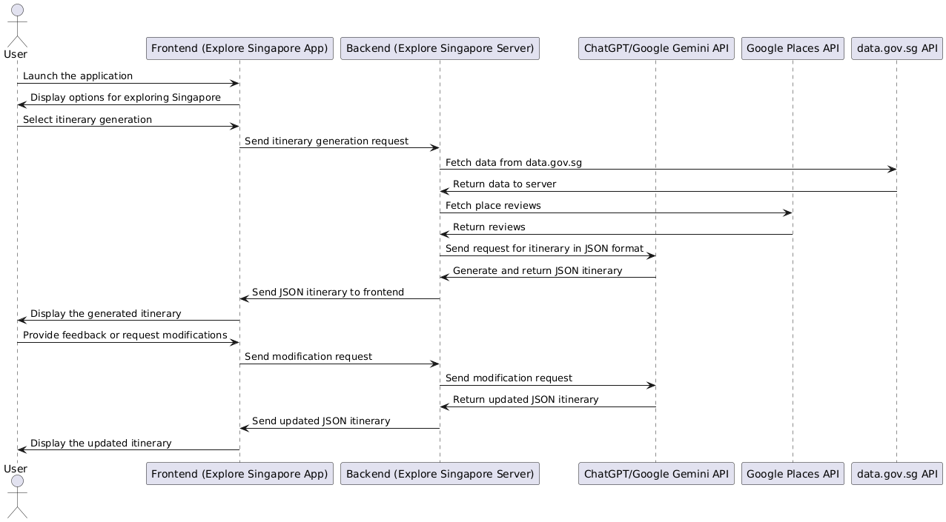

## Components Workflow Diagram

## Build Process Diagram

# Scope of Work

## Key Use Cases

* **Guest Access:** Users can explore the app without signing in to view attractions and sample itineraries.
* **Tourists:** Discover attractions, plan trips, and navigate Singapore.
* **Locals:** Explore events, hidden gems, and new dining options.
* **Complex Use Cases:**
  + Personalized itinerary generation enriched with external data sources.
  + Dynamic recommendations based on real-time data like weather, events, and reviews.
  + Layered exploration of Singapore’s attractions by themes and categories

## Key Features

* A "Today's Page" feature that highlights:
  + User's itinerary for the day.
  + Current weather conditions.
  + Top four headline news items, including relevant alerts such as haze or other important updates.
* ChatGPT-powered itinerary planner.
* Ability for users to save and bookmark places.
* Users can add their preferences and generate personalized itineraries.
* Users can input additional details and modify their generated itineraries as needed.
* Commenting and sharing tips or reviews.
* Interactive maps for navigation and exploration.
* Dining recommendations and access to ticketing systems.
* **Gamified experience**:
  + Users earn points for collecting places.
  + Badges are awarded for achievements within the app.
* **Layered exploration options**:
  + View places by categories such as historical interest or photography spots.
  + Discover popular shopping areas.
  + Explore top-rated dining spots.
  + Uncover kid-friendly attractions.
  + Navigate eco-friendly and sustainable locations.
  + Experience Singapore’s vibrant nightlife.
  + Visit locations featured in movies or TV shows. View places by categories such as **historical interest or photography spots.**
* **Pre-defined itineraries tailored for:**
  + Adventure seekers.
  + Food enthusiasts.
  + Nature lovers.
  + Art and history aficionados.
  + Honeymoon couples.
  + Parents with infants.
  + Retirees.
  + Honeymoon couples.
  + Parents with infants.
  + Retirees.

# Advanced Features:

* Hotel price comparison integration.
* CMS for managing published content.
* Admin portal for content moderation.

# Agile Practices:

* Iterative development cycles to deliver key features incrementally.
* Regular testing to ensure user-friendly design and functionality.
* DevSecOps pipeline to integrate continuous deployment and security practices.

# Demonstrating Complexity:

* Showcase functionally complex workflows, such as integrating multiple APIs (ChatGPT, Google Places, data.gov.sg) to generate dynamic itineraries.
* Highlight secure CI/CD automation for efficient deployment, reducing development effort.

# Effort Estimates

## Work Breakdown Structure (WBS):

1. **Planning Phase:** 2 weeks
   * Finalize project requirements.
   * Design architecture.
2. **Development Phase:** 8 weeks
   * Frontend and backend implementation.
   * API and AI integration.
3. **Testing Phase:** 4 weeks
   * Unit and integration testing.
   * User acceptance testing.
4. **Deployment Phase:** 2 weeks
   * Finalize hosting and deployment.
   * Launch and gather user feedback.

## Task Wise Estimate

|  |  |
| --- | --- |
| **Task** | **Estimated Effort** |
| Planning and workflow Design | 60 Hours |
| UI/UX Design | 60 Hours |
| Frontend Development | 100 Hours |
| Backend Development | 120 Hours |
| CMS Integration | 100 Hours |
| Testing and QA | 80 Hours |

## Sprint-wise Effort Estimation

|  |  |  |
| --- | --- | --- |
| **Date** | **Sprint Focus** | **Team Member Capacity** |
| **Sprint 0**  **Feb 01 - Feb 14** | **Project Kick Start**:   * Create high-level architecture design. * Setup development and continuous build environment. * Setup code & documentation repository. * Create instances & deploy them in the cloud. * Pre-studies on open points and features. * User story creation based on the final proposal & acceptance criteria. * Initial draft of wireframing/UI prototyping. | **Team Member Capacity**:   * >2MD (16hr) each member; * Total: >80hr for whole team |
| **Sprint 1**  **Feb 15 - Feb 28** | **Development, Testing & Integration**:   * Target to complete 25% of the user stories (based on priority). * Meet DoD & fulfill user story acceptance criteria. * Sprint demo, retrospective, and planning. | **Team Member Capacity**:   * >2MD (16hr) each member; * Total: >80hr for whole team |
| **Sprint 2**  **Mar 01 - Mar 14** | **Development, Testing & Integration**:   * Target to complete 50% of the user stories (based on priority). * Meet DoD & fulfill user story acceptance criteria. * Sprint demo, retrospective, and planning. | **Team Member Capacity**:   * >2MD (16hr) each member; * Total: >80hr for whole team |
| **Sprint 3**  **Mar 15 - Mar 28** | **Development, Testing & Integration**:   * Target to complete 75% of the user stories (based on priority). * Meet DoD & fulfill user story acceptance criteria. * Sprint demo, retrospective, and planning. | **Team Member Capacity**:   * >2MD (16hr) each member; * Total: >80hr for whole team |
| **Sprint 4**  **Mar 29 - Apr 11** | **Development, Testing & Integration:**   * Target to complete 100% of the user stories (based on priority). * Meet DoD & fulfill user story acceptance criteria. * Sprint demo, retrospective, and planning. | **Team Member Capacity**:   * >2MD (16hr) each member; * Total: >80hr for whole team |
| **Sprint 5**  **Apr 12 - Apr 25** | **Project Finalization:**   * Ensure the project is fully deployed and ready for demo presentation. * Project report and presentation deck final completion | **Team Member Capacity**:   * >2MD (16hr) each member; * Total: >80hr for whole team |

# Concerns

1. **Feasibility:**
   * Ensuring technical capabilities match the scope of the project.
   * Balancing feature-rich implementation with development constraints.
2. **Reliability of ChatGPT:**
   * Assessing the consistency of responses and handling alias names effectively (e.g., mapping "NUS" to "National University of Singapore").
3. **Data Accuracy:**
   * Aligning AI recommendations with verified data.
   * Providing up-to-date information about attractions.
4. **User Privacy:**
   * Ensuring robust security measures for user accounts and data.